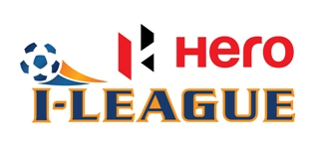

MEDIA ACCREDITATION FORM FOR HERO I-LEAGUE 2016-17

Name:

Organisation:

Designation:

Category (Please tick):

Print | Photographer | Non-Rights Holder  (Videographer)

Please fill in the form and submit to your respective State Football Association: Every application must be accompanied with the following:
  - 2 Colour Passport Photographs.

  - Coloured Photo Copy of Press Identity Card.

